CO1/EXP1/Software
Analysis, Development and Verification of 8-bit and 16-bit Arithmetic Operations Using Assembly Language Program

- Develop and Verification of (i) 8-Bit Addition and (ii) Subtraction Using 8-Bit Microprocessor Assembly Language Programming

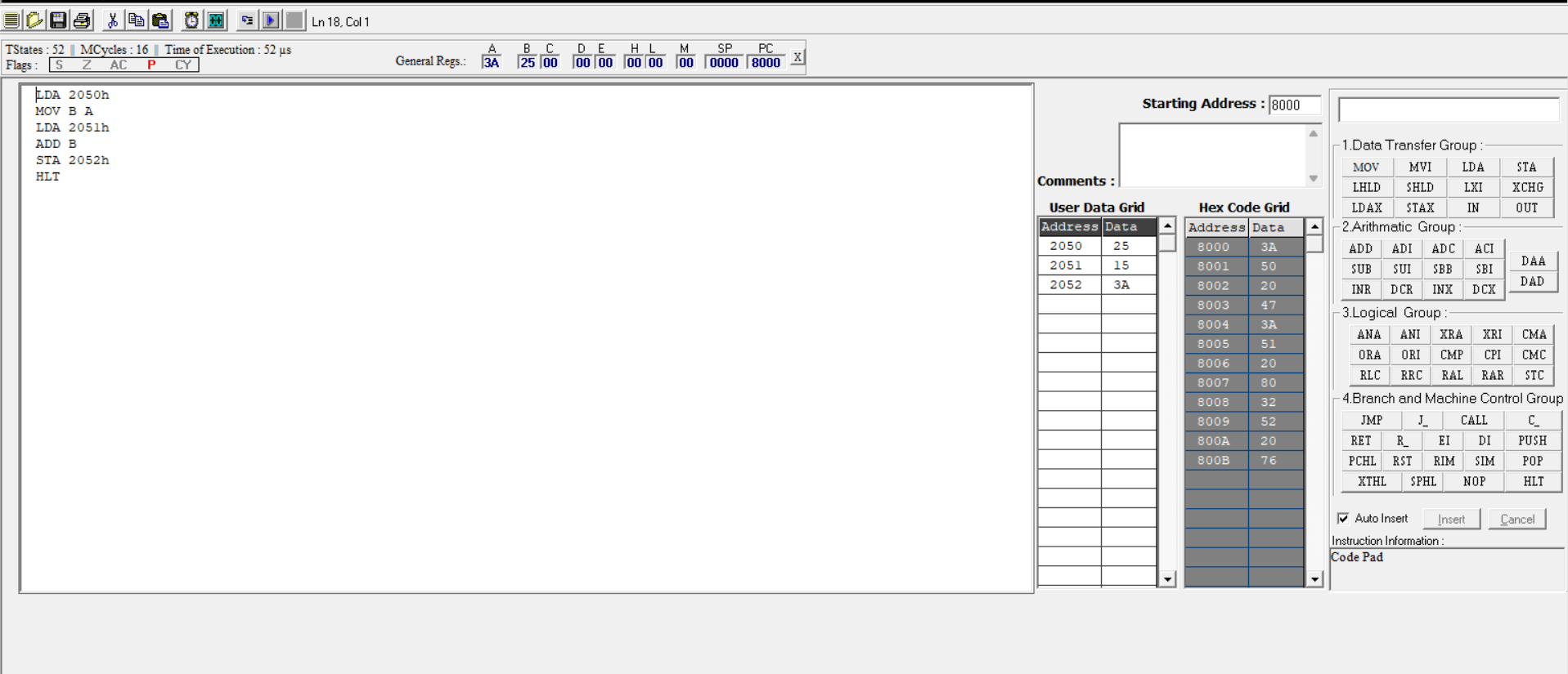

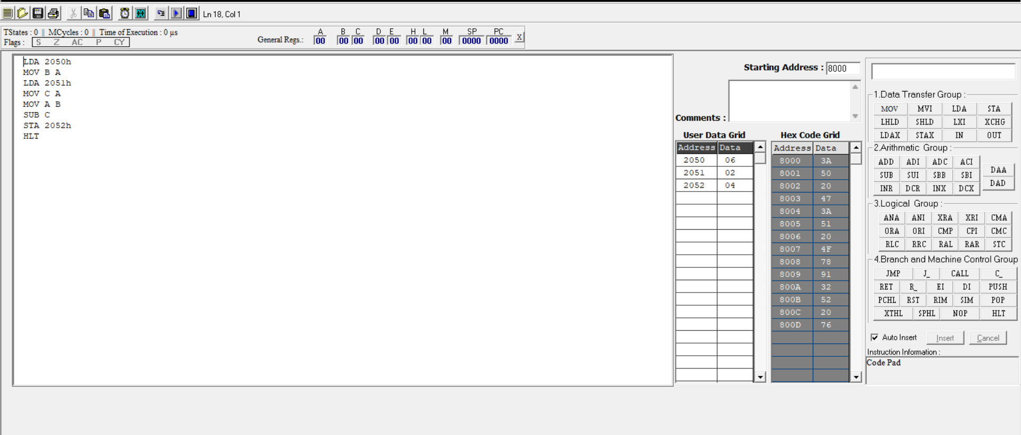

- Verification of (iii)16-Bit Mul and (iv) Division Using 8-Bit Microprocessor Assembly Language Programming



